**University of Information Technology, VNUHCM**

Peer-graded Assignment: Project Part 2: Describing Algorithms Using a Flowchart

Student: Nguyễn Nhật Trường

**TP. HỒ CHÍ MINH, 2021**

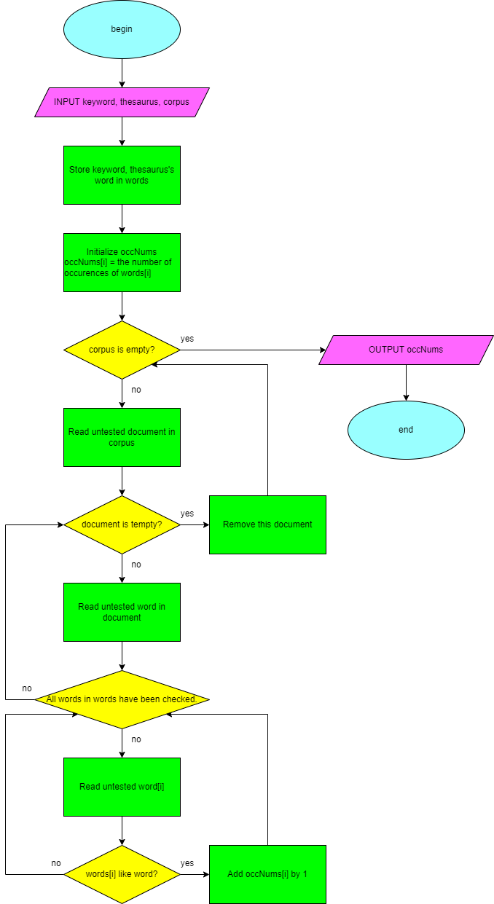

-----------------------**Hết**-----------------------